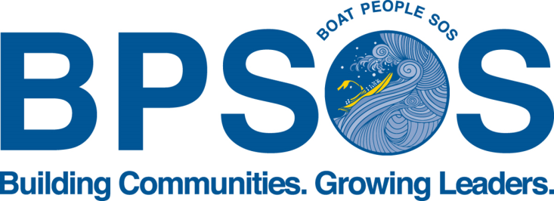

Job Title: Youth Program Intern

Description: BPSOS-Delaware Valley seeks a highly motivated, enthusiastic and responsible intern/volunteer to support our various youth-related projects under our Asian Youth Empowerment Program (AYEP).

The Asian Youth Empowerment Program was developed to help youth learn about the many pressing issues in our community and in our society, as well as compel them to create change within themselves, each other, and the neighborhoods in which they reside.

AYEP Program Interns are part of a seasonal team designed to provide high-quality and rigorous youth programming for 15-50 youth in our various school-year and summer intensive programs. The Interns support Program Staff in the following:

Responsibilities:
- Assess youth readiness for program referrals
- Review the quality of youth enrollment files
- Maintain filing system for youth and provider files, including payroll, timesheets, and other HR paperwork as necessary, including entering data files into proprietary database;
- Supporting Staff in Organizing, planning, and carrying out programming for youth
- Other programming-related support as needed

Requirements:
- Excellent organization skills
- Ability to multi-task in a fast-paced, high-pressure environment
- Bilingual in Vietnamese/English preferred
- Access to transportation preferred
- PC computer literacy, proficient in Word, Excel and Internet usage

Interested? Please send a resume and cover letter to philly@bpsos.org for Philadelphia positions and Camden@bpsos.org for Camden/South Jersey positions.

