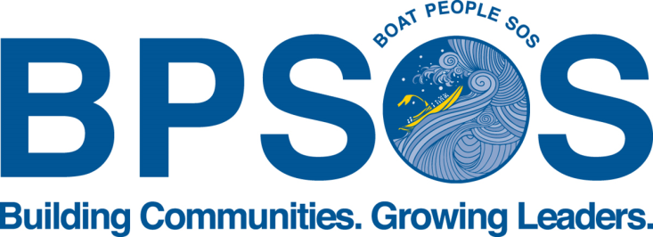

Job Title: SEAYEP Program Assistant

Description: BPSOS-Delaware Valley is currently seeking a highly motivated, enthusiastic and responsible work-study student at Temple University to support our various youth-related projects under our South East Asian Youth Empowerment Program (SEAYEP).

SEAYEP currently serves high school youth by developing and challenging their perceptions of self, society, and world by actively and critically engaging in projects within their various communities in Philadelphia. Youth are encouraged to explore different aesthetic mediums and materials, engage in philosophical exploration, and to study the social trends within and outside of their neighborhood communities.

SEAYEP Program Assistants are part of a seasonal team designed to provide high-quality and rigorous youth programming for 30-50 youth in our various school-year programs. The Assistants support program staff in the following:

Responsibilities:
- Recruit, interview, and support at least 30 Southeast Asian and other minority immigrant youth in the SEAYEP School-Year Program
- Work in a team with other SEAYEP program assistants and report directly to Program Coordinator
- Assess youth readiness for program referrals
- Review the quality of youth enrollment files
- Maintain filing system for youth and provider files, including payroll, timesheets, and other HR paperwork as necessary, including entering data files into proprietary database;
- Embody and integrate excellent customer service into daily work
- Serve as an example of professionalism
- Travel to trainings throughout the City of Philadelphia
- Assist in the development of curricula and program schedules

Requirements:
- Excellent organization skills
- Ability to multi-task in a fast-paced, high-pressure environment
- Bilingual in Vietnamese/English preferred
- Access to transportation preferred
- PC computer literacy, proficient in Word, Excel and Internet usage

Interested? Please send a resume and cover letter to philly@bpsos.org for Philadelphia positions and Camden@bpsos.org for Camden/South Jersey positions.

