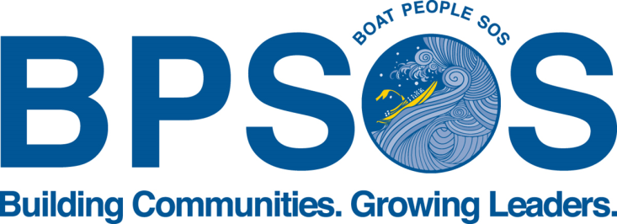

Job Title: Community Arts Project Coordinator

Description: BPSOS-Delaware Valley is currently seeking a highly motivated, enthusiastic and responsible work-study student at Temple University to support our Community Arts Project (CAP) under our Asian Youth Empowerment Program (AYEP).

AYEP currently serves high school youth by developing and challenging their perceptions of self, society, and world by actively and critically engaging in projects within their various communities in Philadelphia. Youth are encouraged to explore different aesthetic mediums and materials, engage in philosophical exploration, and to study the social trends within and outside of their neighborhood communities.

The CAP coordinator will work as alongside AYEP staff to provide high-quality and rigorous youth arts programming for approximately 30-50 youth in our various school-year and summer intensive programs.

Responsibilities:
- Support and potentially recruit Southeast Asian and other immigrant youth into the CAP;
- Organize, plan, and carry out art and humanities seminars for youth;
- Serve as an example of professionalism;
- Assist in the development of art curricula and collaborative art projects;
- Provide technical expertise in various art mediums for students working on art projects;
- Contribute to youths’ understanding of the arts and humanities;
- Assist youth in preparing art for exhibitions and public display.

Requirements:
- Studio art experience;
- Art instruction experience;
- Excellent organization skills;
- Ability to multi-task in a fast-paced, high-pressure environment;
- Access to transportation preferred; and
- PC computer literacy, proficient in Word, Excel and Internet usage

Interested? Please send a resume and cover letter to philly@bpsos.org for Philadelphia positions and Camden@bpsos.org for Camden/South Jersey positions.

